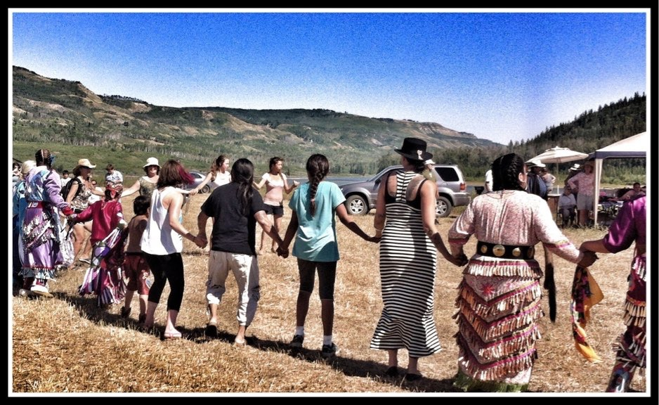

Dear Friend,

We hope you are entering 2015 with the excitement and anticipation of knowing that 2015 is the year that we will put a stop to Site C for good!

Despite the fact that just before Christmas the BC government announced they intend to proceed with Site C, we are confident that it will not come to fruition as six court challenges have been launched against it!

As such, we thought you would appreciate some information on what these court cases are about. We think you’ll agree that they look very solid and have the potential not only to stop Site C, but also to set important precedent for the future of BC and Canada.

Essentially the court challenges are about: holding the federal and provincial governments accountable for the decision making processes that they designed and didn’t follow; and, protecting treaty rights, which have already been seriously eroded due to extensive resource development in northeastern BC.

2 Court Challenges by Peace Valley Landowner Association:
1st: BC Supreme Court Challenge
- Asserts that specific provincial ministers made ‘errors of law’ by failing to consider key findings and recommendations of the Joint Review Panel about the both the need for the project and uncertain economic effects of it, including: project cost; future electricity costs; and, revenue requirements.
  - The province declared that several key Panel recommendations were beyond the scope of the Panel’s mandate; however this is not true! In fact, the Panel was expressly required to assess the economic impacts of the project that were the subject of the recommendations the Ministers chose not to consider.
2nd: Federal Court Challenge
- Asserts that the federal Cabinet cannot have reasonably determined the significant adverse impacts of Site C are justified given that the need for Site C and the economic case for Site C have not been made out (as referred to in the provincial case above).

2 Court Challenges by some of the BC Treaty 8 First Nations:
1st: BC Supreme Court Challenge (sorry, no link available)
- Asserts that the Ministers erred in issuing the environmental assessment certificate without adequately considering the environmental effects, including the cumulative effects of the project and the adverse impacts of the Project on Treaty rights that cannot be mitigated.
2nd: Federal Court Challenge
- Asserts that the significant adverse environmental effects of Site C on Treaty rights cannot be justified in the circumstances, especially given that the Treaty rights are proven and according to the Joint Review Panel, unmitigable.

Note: In addition, Treaty 8 First Nations from Alberta have also launched two lawsuits against Site C at the federal level.

We are feeling very optimistic about the court challenges that have been launched by the Peace Valley Landowners Association and the BC Treaty 8 First Nations. The challenges are very straightforward and based on clear, solid arguments.

Additional updates

- BC Hydro has delayed the construction start date for Site C until ‘summer 2015’; initially they had intended to start in January 2015. We believe that this action is a reflection of their concern regarding the significance that the court cases present.

- Since the provincial announcement to proceed, we’ve noticed an unprecedented number of articles in various media from pro-Site C construction interests justifying the need for the project. We believe that they too, are very concerned about the likelihood of the project coming to fruition.

- Interestingly, a number of other business interests throughout the province are very much against the dam.

- A recent article in the Globe and Mail states that BC Hydro’s CEO, Jessica McDonald recently attended a Vancouver Board of Trade luncheon where, in response to questions about a contingency plan if Site C is delayed or struck down in the courts, she said, “Our plan is to build Site C, and as I said before we’re moving forward with implementation.”

Our voices need to be heard! If this comment from Hydro’s CEO riles you like it does us, please send a letter to the editor of the Globe and Mail and let them know what you think. Email them at: letters@globeandmail.com.

Thank you for your on-going support to protect all British Columbians from the unnecessary economic and environmental devastation that this project would cause. Please share this information update with your friends, family and networks to ensure that all British Columbians take a stand against this unwarranted project.

For the Peace,
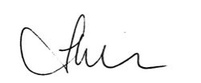

Andrea Morison
Peace Valley Environment Association

P.S. Don’t forget to share!

